April 2010
Volume 10 Issue 4
RUSTY ROCKET REVIEW


Sharon Cunning
April 6
Birthday
Maxine Bishop
April 13
Birthday

Food Distribution
Tuesday
April 27
4:45 – 6:00
Center for People in Need

Life is like a shower. One wrong turn and you end up in hot water.

Don’t complain about growing old. The privilege is denied many people.

A Publication of Northeast Sertoma, Lincoln, NE

Chapter 1

The audiologist rechecked the connections and made sure the earpieces were still firmly positioned in Sam’s ears. Even as the noise being pumped directly into his head became audible to the rest of us, our infant son slept.

Limp lines crossed the computer screen for half an hour, and I got the sinking feeling the audiologist only continued to stare at them to avoid making eye contact with my wife and me. She was girding herself to share bad news.

Only three months earlier, our second child, Sam, was born and we enjoyed one of the happiest days of our lives. This day was one of the saddest. The fear that we both carried but largely avoided discussing was confirmed: Sam was deaf.

Now, Sam is almost a year old and we’re quickly approaching the day he will receive a cochlear implant. It’s an exciting time for our family. The pain we felt on the January morning when his hearing loss was confirmed faded as we learned about hearing loss and how the implant would help Sam navigate a hearing world. Information has been our lifeblood, and we hope sharing our story benefits others who face similar situations.

A New Reality

With no family history of hearing loss, my wife, Teresa, and I never considered the possibility that we might have a child who was deaf. And when Sam failed his newborn screening the day after he was born, the woman who performed the test told us inaccurate results were common. A month later, Sam failed another screening at our pediatrician’s office. The audiologist explained that the parts of Sam’s inner ear worked, but the equipment wasn’t showing a response from the tiny hair cells inside his cochlea. Leftover fluid from birth was the likely culprit, he said.

Any explanation seemed reasonable because the idea that our son could have a significant hearing loss seemed so unreasonable. Still, we were coming to grips with that reality. Medical professionals, family, and friends all asked the same question: Does he respond to loud noises at home? Each time we answered that question, we were forced to be a little more honest with ourselves.

Whether Teresa yelled his name from across the room or I clapped my hands just behind his head, Sam never budged. We debated his blinks and gestures, but we were just being wishful. That became clear at the third hearing screening, when the audiologist was noticeably somber. There were no new possible explanations to consider this time, just a recommendation that we make an appointment with a children’s hospital for a more involved test.

On January 9, we arrived at the hospital for ABR (auditory brainstem response) test. The audiologist escorted us from the waiting area to a dimly lit room filled with computer equipment and wires. In a soft voice, she explained the test and told us it would take about an hour. It didn’t.

Her demeanor was a comfort as we settled for the test, but as the test wore on we could read the growing disappointment in her face. Teresa was sobbing and I was choking back tears as the audiologist turned to us to explain the outcome.

COCHLEAR IMPLANTS – HELPING SAM HEAR

Surprise! The League of Women Voters is also open to men, since 1972.

Lois Poppe said the League began with the Suffrage movement in 1920 when the 17th amendment was passed which allowed women the right to vote. It was formed to educate women on voting and was expected to have a five year limit.

The goal is to inform active citizens in government, and influence public policy through education and lobbying. It advocates the respect of individuals and the power of diversity.

The League endorses voter registration as their service. Voter information forums are non-partisan and do not support any candidates. One of the main issues in Lincoln is the new arena.

They also monitor elections to make sure the right procedures are followed and that people vote in the right way. Some members have gone to new democracies around the world to assist in elections. They lobbied for 35 bills this year, 16 carried over from last year. The hot national issue right now is health care reform.

There is a lunch and learn very month. They also provide a directory of elected officials.

Voters should vote on issues for which they are familiar.

LEAGUE OF WOMEN VOTERS

Trail Pickup

MoPac Trail from 70th to Wedgewood Bridge

April 1 - 30
Sharon Cunning

Superior Trail

April 1 - 30
Dave Taylor
Ken Westerhold

Program Schedule

April 1
Tom Johnson
The Nebraska Lottery

April 8
Jason Anderson
Cornhusker Council of Boy Scouts of America
100th Anniversary Program & Activities

April 15
TBD

April 22
TBD

April 29
TBD

University Club & Mid Towne Club are selling geraniums.

Learn to dance in the rain and appreciate the abundance in life.

Appreciation is a never-ending story, where the brain feeds the energy of the heart, says Debbie Way, Director of Community Outreach for Roper & Sons.

The practice of appreciation enhances health and well-being. The news tells us what to fear, but it is impossible to be unhappy in a state of appreciation.

First love relationships cause an intense feeling of appreciation. Eventually, we see more faults and the relationship deteriorates. Appreciation can turn it around. Make a list of positive aspects. It trains the brain to see more good of a person.

We need to first love ourselves and appreciate who we are as an individual. We can’t see it in other people, if we can’t see ourselves.

To practice appreciation, we need to:
Appreciate life;
Realize the beauty of people; and
Appreciate self and others.

THE ATONISHING POWER OF APPRECIATION
Break the cycle of poverty through education programs. That is the goal of City Impact says Jo Sheets.

If a child is behind the reading level at fourth grade, there is a 40% higher risk of criminal activity. Because of the high mobility of the poor, many are not reading at grade level. City Impact has a reading center/tutoring program at Elliott, Clinton and Hartley schools. There are 150 volunteers and requires a 1-2 hour training session. The child is tutored every day but the volunteer works once a week.

The Impact Leadership Academy is for teens. It helps build self-confidence, how to rise above the circumstances and how to give back to the community.
Strengths for Life Mentoring is a monthly mentoring program to help students to get into college.

The logo shows how the impact ripples outward to family, the neighborhood and the community.

Gifts of Love at Christmas lets families buy gifts for each other with dignity at a fraction of the cost because of the donations of others.

CITY IMPACT

Sertoma Launches Subsidiary:
Hearing Charities of America

To expand Sertoma’s mission and brand as the premier hearing health service organization, Hearing Charities of America was formed. This new not-for-profit arm will allow the mission to flow into areas where Sertoma has no presence and to develop new tools and relationships for Sertoma and our clubs.

Hearing Charities of America will launch in April, in time to participate in Better Hearing and Speech Month in May. They will collaborate with other hearing health not-for-profits, associations, manufacturers and government agencies and offer a web site that brings together resources from all these entities to help educate, build awareness and engage people in action campaigns across the US.

Along with the launch, Hearing Charities of America is also launching Celebrate Sound, an awareness campaign focused on what hearing is, how it works and the importance of protecting the gift of sound. It will educate the public about hearing – how to protect it and how to get involved. At the website, visitors will have the opportunity to visit the Hearing Charities of America side of the website to learn more. The goal of the Celebrate Sound campaign is to inspire more of the public to take a greater interest in hearing as a health concern. Sertoma clubs will benefit from this increased interest in the Sertoma mission of hearing health as Sertoma holds a special position on the web site as the founding partner of HCOA.

A Sound Investment, an action campaign will also be launched. It focuses on an access issue for the deaf and hard of hearing. It will generate awareness and take action related to induction looping, a process that allows individuals who have hearing devices with a t-coil to tune in and more clearly understand communications broadcast over sound systems.

SERTOMA INC & DISTRICT NEWS



Cookies for Child Advocacy Center

April
Fran Follett

Board Meeting

April 13
John Shimonek, Host

The Eiffel Tower is the Empire State Building after taxes.

I just did my taxes and I’m getting back $150,000. And people say you can’t do your own taxes.

Too many people spend money they haven’t earned, to buy things they don’t want, to impress people they don’t like.
Will Rogers

Money frees you from doing things you dislike. Since I dislike doing nearly everything, money is handy.
Groucho Marx



I don’t get these people who, instead of buying a four or an eight-pack of toilet paper, buy the single, individual roll. Are they trying to quit?

My sister’s got asthma. In the middle of an attack, she got an obscene phone call. The guy said, “Did I call you or did you call me?”

If you are truly serious about preparing your child for the future, don’t teach him to subtract – teach him to deduct.

A brother of a student of mine showed me a photo their father had sent from Iraq. In it, his dad is sitting atop a tank. On the back of the tank is this bumper sticker: “My son is an honor student at Clear Creek Elementary School.

What’s My Motivation?

Character descriptions for voice-overs:

We’re looking for the voice of God, but not a goofy God, a real God.

Female voice. American. Sultry, like drinking chocolate from the back of a moose.

Ms. Pancake of the Hour
Sharon Cunning
Doesn’t she look delicious?!

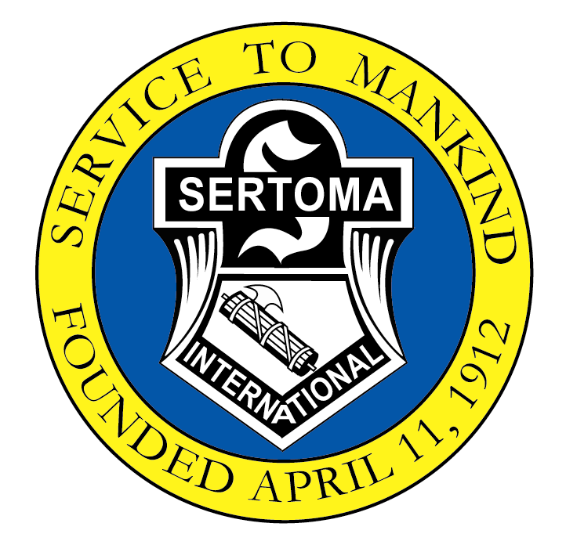
2007-2008 Officers

President – Ken Westerhold

President-Elect
Cathy Becker

Chairman of the Board
John Shimonek

Secretary – Fran Follett

Treasurer – Lee Bring

Sergeant-at-Arms
Harland Parrish

Board of Directors
Jim Becker
Dave Brown
Sharon Cunning
Chuck Genrich
Donna Magwire
Harry Wimer

Meet Thursdays
7:00 a.m.
HyVee Club Room
5010 “O” Street

Website: nesertoma.org

LAUGHTER

Fran Follett
1741 Ridgehaven Court #1
Lincoln, NE 68505-3060
Phone: 402-325-6788 home
Phone: 402-421-4177 work
Email: jfollett@neb.rr.com

Northeast Sertoma

My GPS Voice is...

Jack Bauer: I don’t have a lot of time. You’re going to have to trust me. The country’s fate is in my hands. So please, listen to me. The Walmart is on the left, 2.6 miles up the road. Today’s the last day for the rollback prices on that wicker hamper you want, so grab it and go. Then we have some business to take care of.

To get his mind off his losing streak at the racetrack, I took my friend horseback riding. Being a novice, he freaked when his mount took off.

“How do I stop?” he yelled.

“Bet on it!” I hollered back.

Seen outside a professor’s door at Georgetown College:
“Psychology 376: Dying, Grieving, and Coping. Take for your major or minor, or as a fun elective.

A woman is brought to court after stealing from a supermarket.
“Mrs. Krupnick,” says the judge, “what did you take?”
“Just a small can of peaches,” she answers. “There were only six peaches in the can.”
“Six peaches…hmm…I sentence you to six nights in jail, a night for each peach.”
The woman is crushed. She’s about to collapse to the floor when her husband, seated in the gallery, leaps to his feet.
“Your Honor,” he shouts, “she also stole a can of peas!”

CONFERENCES 2009-2010

Regional Convention
April 29 – May 1
Minot, ND

International Convention
July 2010
San Antonio, TX

Wisdom outweighs any wealth.
Sophocles

Northeast Sertoma
Fran Follett, Editor
1741 Ridgehaven Ct #1
Lincoln, NE 68505-3060
The reason volunteers aren’t paid isn’t because they’re worthless, but because they are priceless.

